Assignment 1003

1. **Write 4 data types for storing strings and when to use.**

|  |  |  |
| --- | --- | --- |
| **DATA TYPE** | **BEST USED** | **EXAMPLE** |
| **VARCHAR** | Varying data entries and is not Unicode. | Names, Address, States, Businesses, etc. |
| **CHAR** | Set number of English data entries | Zip codes, Social security numbers, mobile numbers etc. |
| **NVARCHAR** | Storing different languages (Unicode) | Any language other than language the system supports. Ex.- any language other than English |
| **NCHAR** | Fixed length and supports different languages | Fixed number of Japanese, Spanish, French entries |

1. **What is a cloud platform and its uses?**

A cloud platform is a virtual platform that allows the usage of servers, databases, software, networking, etc., to assist with our personal and business computing needs. It is like having an additional computer only in a virtual capacity.

**What are 5 different cloud platforms?**

* Azure
* AWS
* GCP
* Salesforce
* Workday

1. **Create 2 database HRMS and CS.**

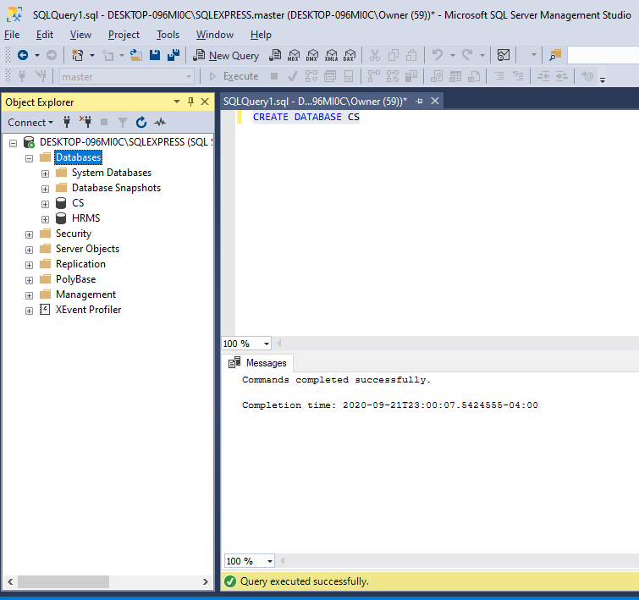

1. **Declare and assign values for integer datatype, and varchar data type.**

